NORTHUMBRIAN CAMBRIDGE ASSOCIATION

ANNUAL DINNER
Wednesday, March 14, 2018, 6.30 pm
at the Northern Counties Club, 11 Hood Street, Newcastle upon Tyne NE1 6LH

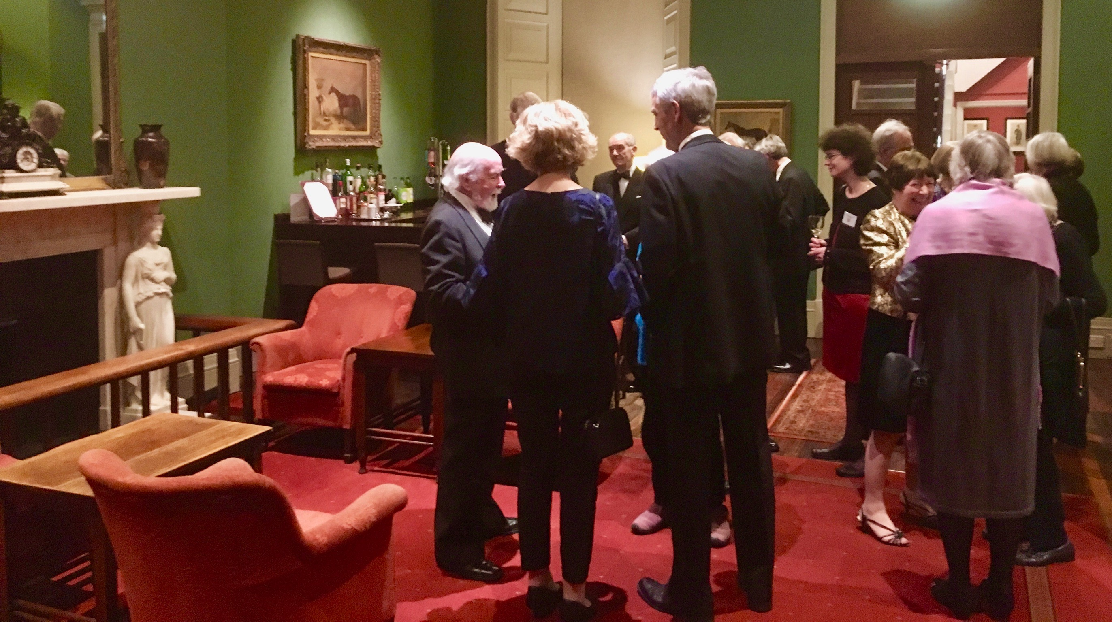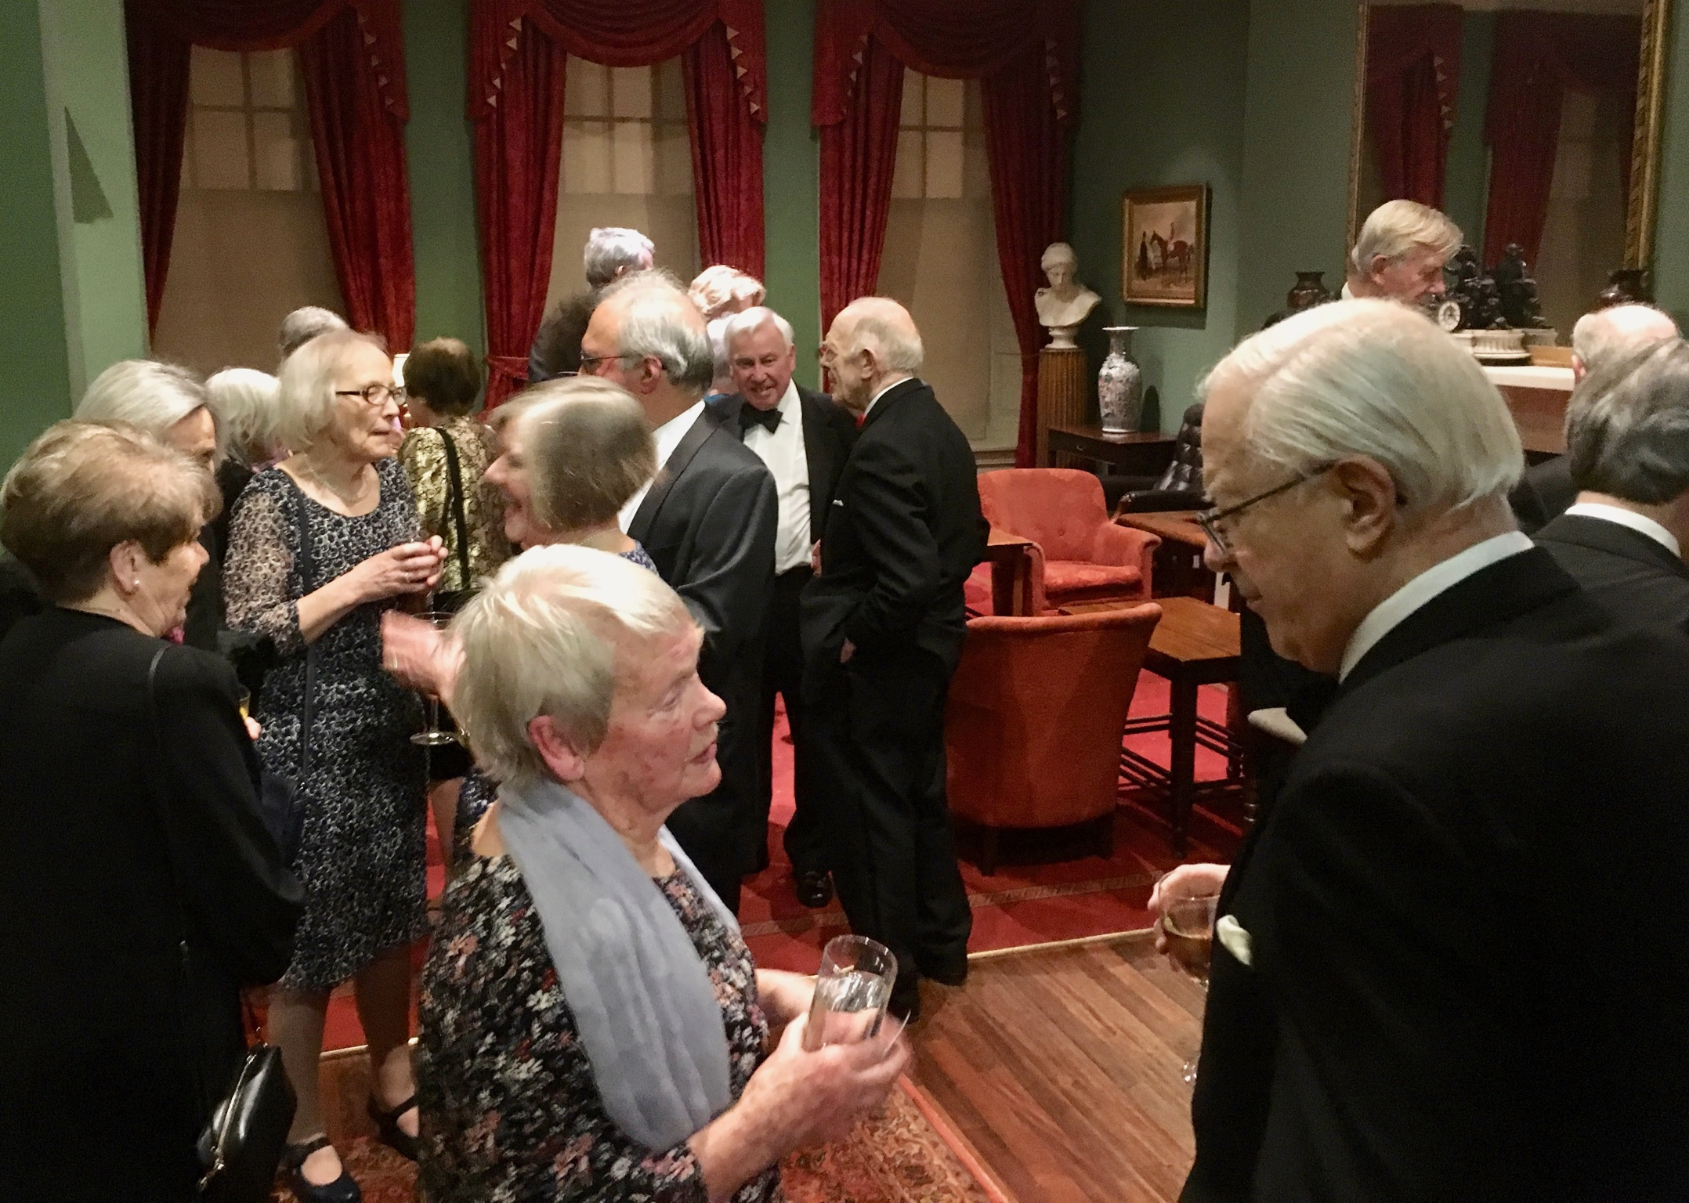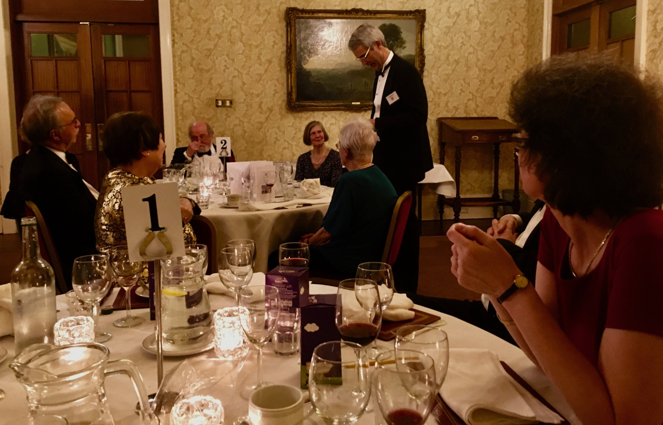

This year’s annual dinner of the Northumbrian Cambridge Association will once again be held in the splendid surroundings of the Northern Counties Club in the centre of Newcastle, and will be a black-tie affair as usual. We have dined here for the last three years and we look forward to returning. Once again the Club’s excellent young chef will provide a three-course meal, followed by coffee/tea. There will be an allowance of 2 glasses of wine (or equivalent) per person for a pre-dinner drink and at the table (other drinks can be ordered at the time). The cost for the dinner will be £35. The meal will be a set menu but vegetarian/special dishes will be available with prior notice. The menu will be circulated ahead of time to those attending. After the dinner, there will be more Cambridge reminiscences, this time given by our Membership Secretary, Judy Vigurs, and our Treasurer, Dr Ray Brown. And, of course, there will be another challenging quiz!

Other guests, including family members and friends, are of course welcome at the dinner. To sign up, kindly complete the form below and send [TO ARRIVE BY Wednesday, February 28, PLEASE] either by email to:
aeandwr.telford@btinternet.com
or by post to: Dr Andrena Telford, Ladywell Cottage, 24 West Road, Ponteland, Northumberland NE20 9SX.

If an acknowledgment is required by post, please include a stamped, self-addressed envelope.
Payment can be made by cheque, made out to Northumbrian Cambridge Association, or electronically to: HSBC account no. 60618446; sort code 40-34-18 (please give your name as reference and mark it ‘Dinner’).
________________________________________________________________________________
NORTHUMBRIAN CAMBRIDGE ASSOCIATION ANNUAL DINNER 2018 - BOOKING FORM
Please reserve ........ places at the Annual Dinner on Wed., 14 March, 2018, at the Northern Counties Club, Newcastle, at £35 per person.
Name(s): __________________________________________________________________________________
Address: __________________________________________________________________________________
Telephone No.: ___________________ Email address: ____________________________________________
Names of Guests: ____________________________________________________
_____________________________________________________
I/we enclose a cheque for £ _____ made payable to the Northumbrian Cambridge Association (full title, please; not NCA).
I/we require an acknowledgment by post and enclose a stamped, self-addressed envelope: YES/NO
I have made an electronic payment to HSBC account no. 60618446; sort code 40-34-18
Special dietary requirements (vegetarian; other): ________________________________________________
I/we would like, if possible, to sit near the following at the Dinner: __________________________________
Map/Parking instructions required: YES / NO

