NORTHUMBRIAN CAMBRIDGE ASSOCIATION
SUMMER OUTING 2018
Togston Hall East Lodge and the Seaside Town of Amble, Northumberland

Saturday, June 9, 2018
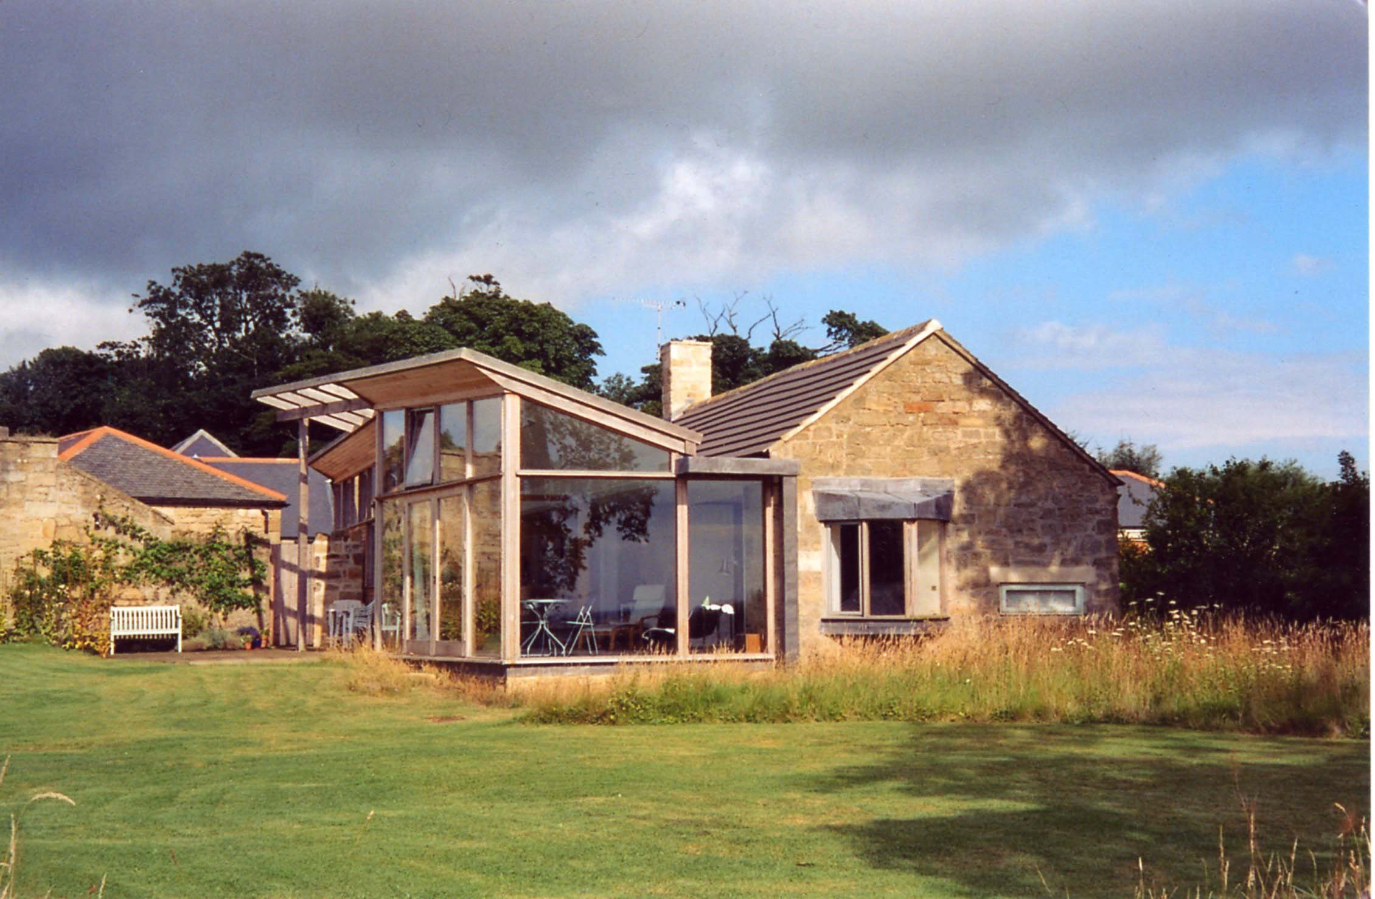
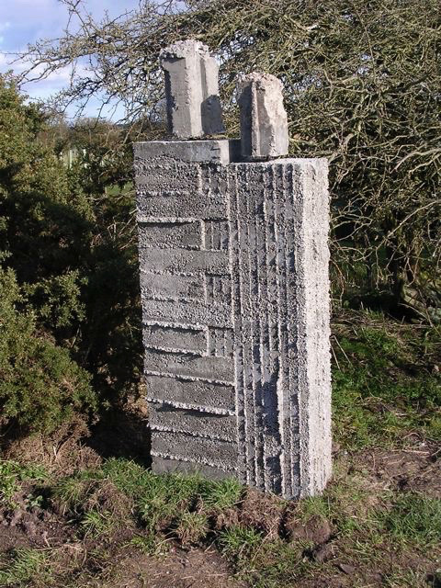
This year’s summer outing promises to be very special. for the Association has received an invitation from one of our own longtime members, Professor Roger Stonehouse, to visit his home and garden at Togston Hall East Lodge, North Togston, Morpeth, NE65 0HR. Roger was Professor of Architecture at the Manchester School of Architecture (1983-2006) and (co)author, among other things of ‘The Architecture of the British Library at St Pancras’ (2004). Roger designed Togston East Lodge himself, converting it into a modern building that is an admirable blend of traditional Northumbrian and contemporary style. Attached to the house is a sculpture garden. Togston Hall East Lodge is close to Amble, and there is a bus that stops some 200 m away. However, most members will wish to come by car, and lifts can be arranged for those without transport. A map will be sent to all those who book for this event. The postal code for SatNav is NE65 0HR. Roger and Adrienne will receive us at 10.00 am and we will be given a tour of this fascinating house and garden.

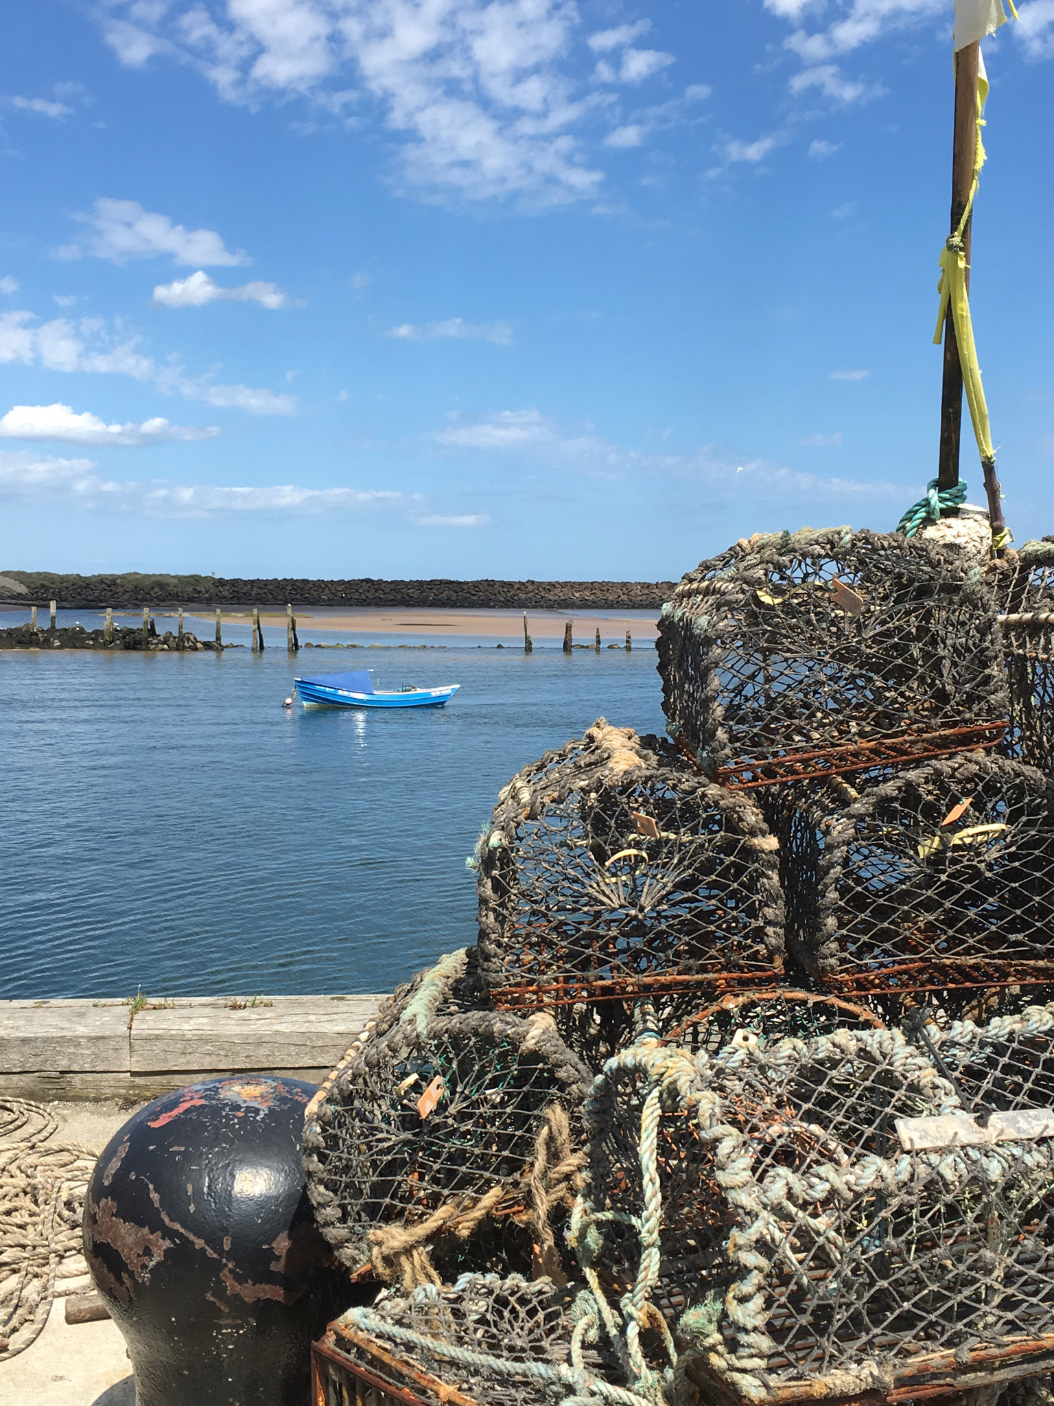
Following our visit to Togston East Lodge, we will travel the short distance to Amble for lunch at 12.30 at the Old Boathouse, one of Britain’s premier seafood restaurants, and ‘Coastal Fish Restaurant of the Year’ in the 2016 and 2017 Fishing News Awards. Lunch will be self-financing but menu choices will be sought in advance. After lunch there will be an opportunity to explore the port of Amble, with its attractive and popular Harbour Village, including the Northumberland Seafood Centre, shopping pods and Lifeboat Station. There will be an hour-long guided walk for those who wish it (Amble’s Green Trail), led by Bill and Andrena Telford, followed by a visit to the famous Spurelli’s for ice-cream.

There will be no charge for the visit to Togston East Lodge, but we will need notice of the numbers attending. To book, please return the form below, either by post or electronically, TO ARRIVE BY Wednesday, May 30, PLEASE, to:

Dr Andrena Telford, Ladywell Cottage, 24 West Road, Ponteland, Northumberland NE20 9SX; telephone: 01661 825437; email: aeandwr.telford@btinternet.com
--------------------------------------------------------------------------------------------------------------------------------------------------------
NORTHUMBRIAN CAMBRIDGE ASSOCIATION SUMMER OUTING: BOOKING FORM
Togston Hall East Lodge & Amble, Saturday, June 9, 2018
Name: _________________________________________________________________________________________
Address: _______________________________________________________________________________________
Guests: _______________________________________________________________________________________
Telephone: _______________________ Email: _______________________________________________________
No. in party: _________ No. of adults:_________ No. of children: ________ No. for lunch: ___________
Would you like a lift to the venue? YES / NO
Would you be able, if called upon, to offer a lift to someone else? YES / NO

